A machine named Metaspolit framework given to you.  
  
**Task 1:**Login to metaspolit and extract ip address  
**Task 2:** Do nmap scanning on the IP, Extract Open port and Version Details  
**Task 3:**Check the vulnerable version exploitation's procedure in rapid7 and start exploiting the following ports  
A)Telnet  
B)FTP  
C)SSH

**SOLUTION:**

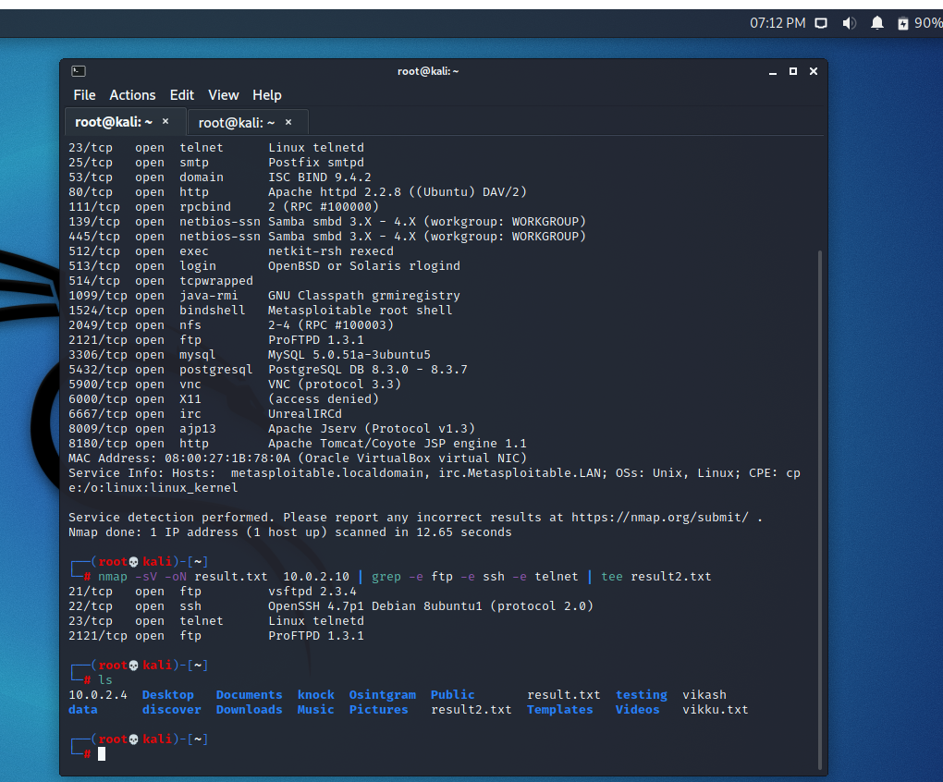

1. **FTP:**

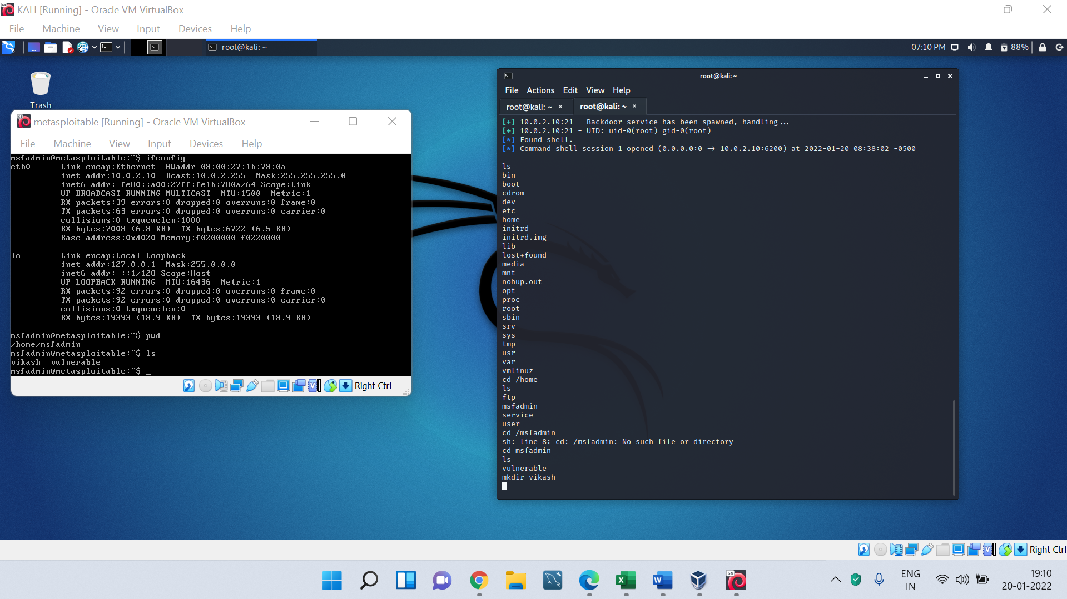

1. **telnet:**

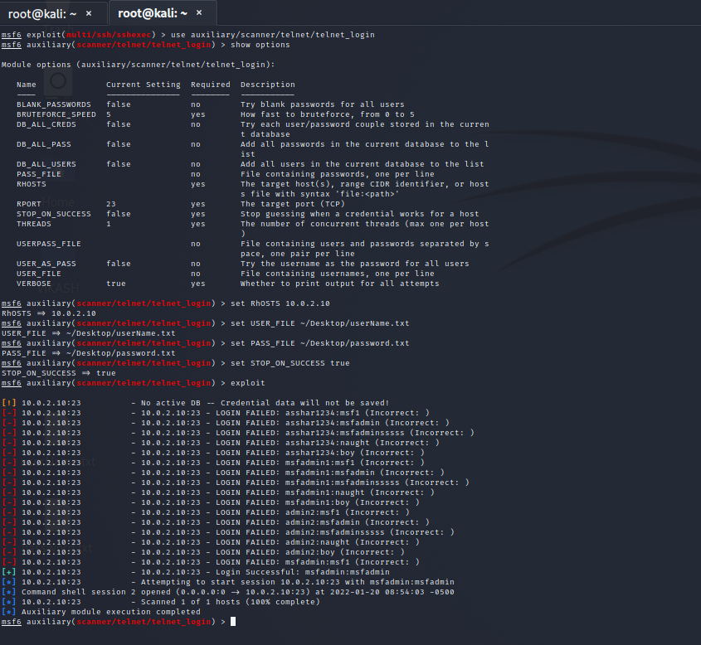

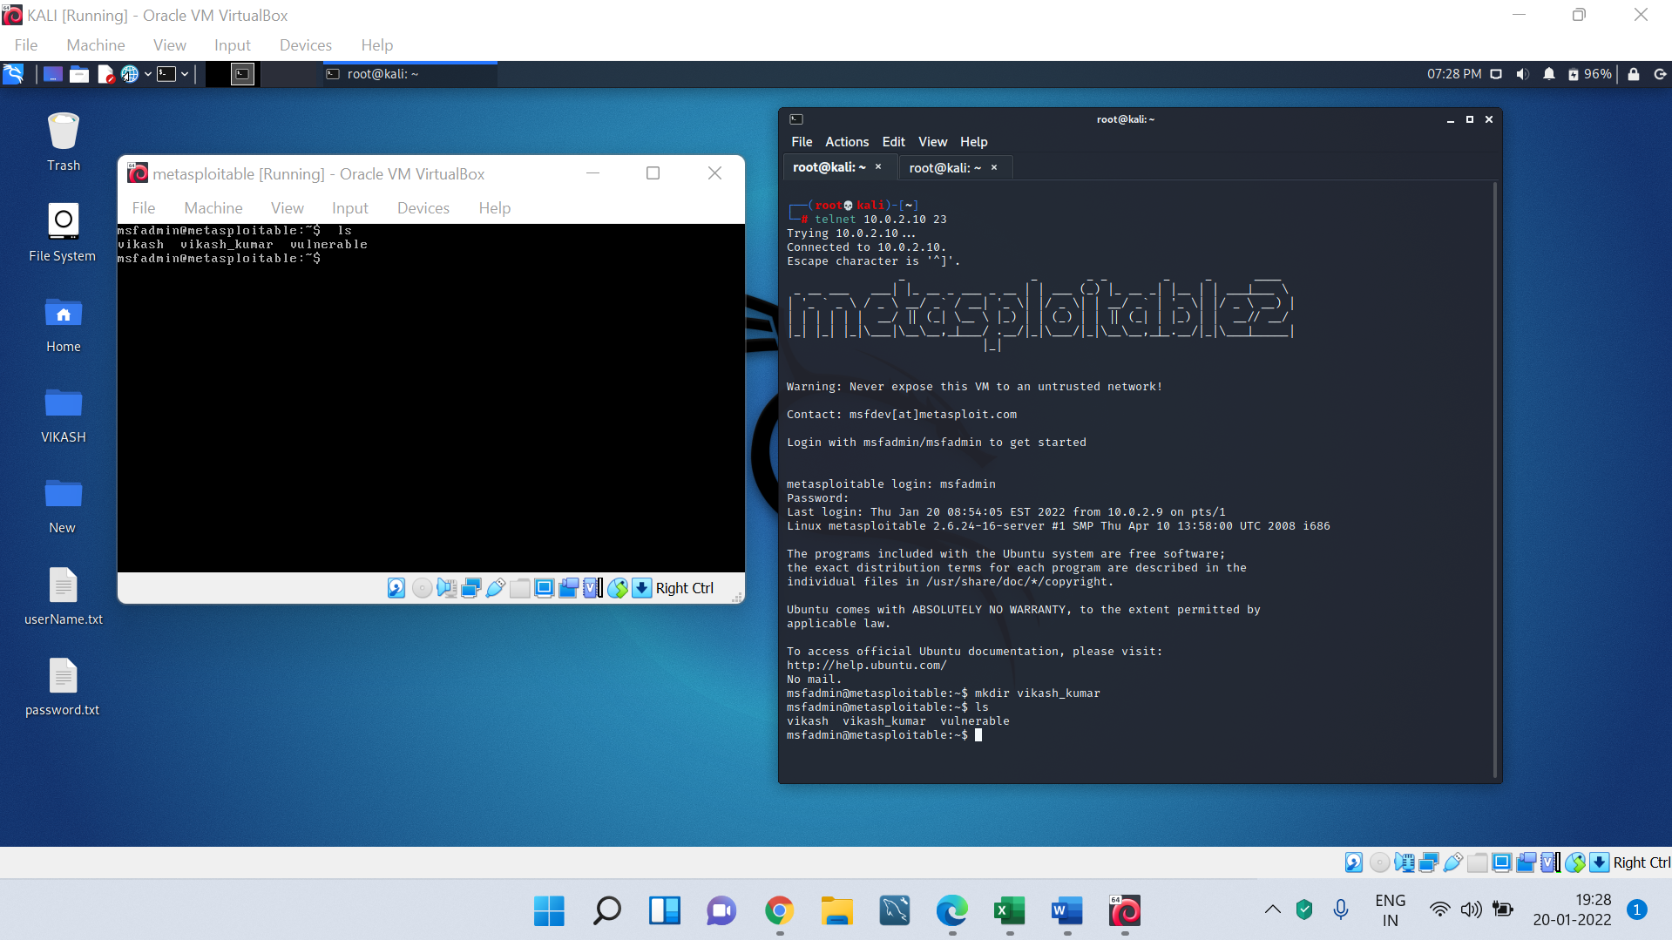

1. **SSH**

